# Problem 3 - Spice Shelf

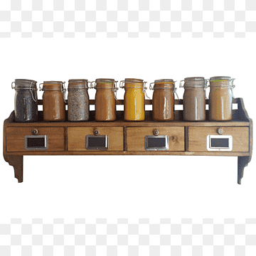

*John loves cooking, the secret of his great meals is the variety of spices which he uses. Because he has so many of them, it is hard for him to keep them organized. Help him to organize his spices.*

Create a program that organizes a collection of spices, by given commands.

You will be given **a sequence of strings,** representing **different spices**. Next, you will receive one of the following commands:

* **AddSpice {spice}** - add a given spice at the end of the **sequence.** If the spice **already exists**, skip the command.
* **AddManySpices {index} {spice1|spice2|spice3|spicen}** – insert all the given spices at the given index. The index and all the spices will be valid.
* **SwapSpices** **{spice1} {spice2}** – find the given spices in the **sequence** if they exist and swap their places.
* **ThrowAwaySpices {spice} {number of spices to remove} –** If the given spice exist, remove the number of spices, by starting from the given. The number of spices to remove will be always valid.
* **Arrange** – sort the spices alphabetically.

The program stops when the "**done**" command is given. At the end print the last state of the sequence.

### Input

* On the **first line**, you will receive a sequence of **strings** representing different spices, **separated** by comma and space (**", "**).
* **On the next lines**, you are going to receive **commands**, until you receive the "**done**" command.

### Output

* Print the last state of the sequence, split by a single space.

### Examples

|  |  |
| --- | --- |
| ****Input**** | ****Output**** |
| coriander, cloves, paprika, allspice, turmeric, anise, cumin  AddSpice nutmeg  ThrowAwaySpices cloves 3  AddManySpices 3 cayenne|cardamom|mace  done | **coriander turmeric anise cayenne cardamom mace cumin nutmeg** |
| ****Comment**** | |
| The first command is **AddSpice**: we add nutmeg at the end of the **sequence:**  coriander, cloves, paprika, allspice, turmeric, anise, cumin, nutmeg  The next command is **ThrowAwaySpices**: we search for cloves, and when we find it we remove three spices (cloves, paprika, and allspice).  The state of the **sequence after the command:**  coriander, turmeric, anise, cumin, nutmeg  The next command is **AddManySpices**: we should insert cayenne, cardamom, and mace at **index 3**  The state of the **sequence after the command:**  coriander, turmeric, anise, cayenne, cardamom, mace, cumin, nutmeg  The "**done**" command is given, so the program stops and we print the final state of the **sequence**. | |
| **Input** | **Output** |
| **coriander, cloves, paprika, cumin**  **AddSpice nutmeg**  **AddSpice anise**  **AddSpice turmeric**  **AddSpice cumin**  **SwapSpices coriander paprika**  ThrowAwaySpices **cumin 4**  **done** | **paprika cloves coriander** |